CSE484 – Final Examination (120 minutes)
School of Computing and Information Technology Course Code: CSE 484 | Exam Code: 04 Maximum Marks: 100 Type of Exam: Practice on Computer / Open Book

Instructions
- Non-programmable calculator: No
- This paper contains 5 questions, each worth 20 marks
Submit a ZIP containing:
- All Python scripts
- Ansible inventory + playbooks
- Nornir inventory + scripts
- API output files (RESTCONF/NETCONF)
- Screenshots showing execution
- All automation must be performed on CSR1000v

Section 1 — 100 Marks

Question 1 — Python Automation & CLI Handling (20 marks)
Write Python programs that interact with CSR1000v using automation libraries.
Tasks
- Create a Python virtual environment and install: netmiko, paramiko, pexpect
- Using pexpect, write a script that:
  - Connects to CSR1000v via SSH
  - Runs: show ip route static
  - Handles paging (e.g., --More--)
  - Saves the output to static_routes.txt
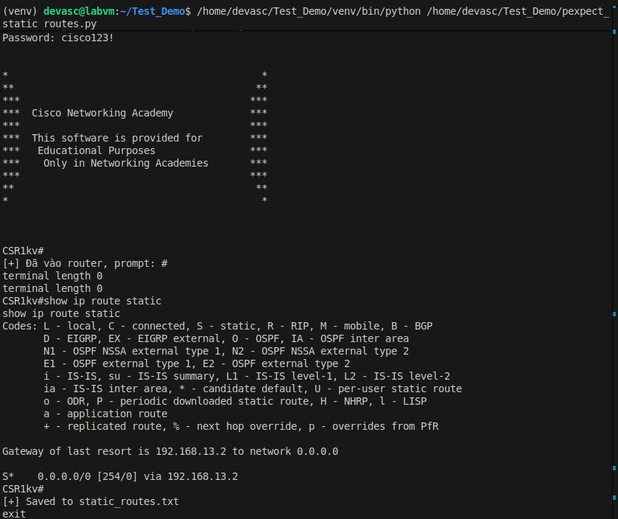
- Using Paramiko, write a second script that:
  - Logs into CSR1000v
  - Runs: show version | include uptime
  - Extracts and prints only the uptime line
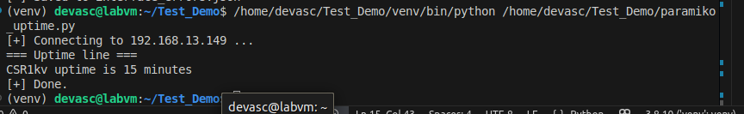
Deliverables:
- pexpect_static_routes.py
- paramiko_uptime.py
- static_routes.txt
- Execution screenshots

Question 2 — Netmiko & Nornir Device Interaction (20 marks)

Part A — Netmiko
Write a Python script that:
- Connects to CSR1000v
- Runs: show interfaces counters errors
- Parses output using use_textfsm=True
- Saves structured JSON to: interface_errors.json
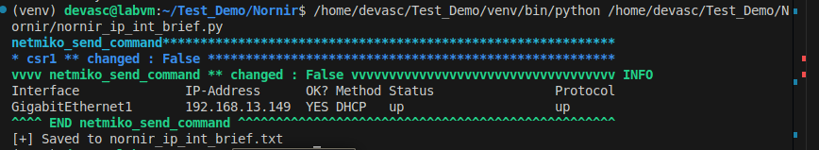

Part B — Nornir
Students must prepare Nornir to run one command on CSR1000v.
Required Nornir Files
- config.yaml: Must specify SimpleInventory and reference hosts.yaml and groups.yaml.
- hosts.yaml: Must include CSR1000v hostname/IP, username/password, and group assignment.
- groups.yaml: Must include Netmiko connection settings and device_type for IOS-XE.
Nornir Script Requirements The script must:
- Load Nornir via: InitNornir(config_file="config.yaml")
- Execute: show ip interface brief
- Print output using print_result()
- Create a summary file nornir_ip_int_brief.txt containing each interface name and status.
Deliverables:
- Netmiko script
- interface_errors.json
- config.yaml, hosts.yaml, groups.yaml
- Nornir script
- nornir_ip_int_brief.txt
- Screenshots

Question 3 — RESTCONF & NETCONF API Automation (20 marks)

Part A — RESTCONF
Write a Python script using requests that:
- Retrieves routing protocol information from: /restconf/data/ietf-routing:routing
- Prints the list of routing protocols
- Saves full response to: restconf_routing.json

Part B — NETCONF
Write a Python script using ncclient that:
- Retrieves hostname + domain name using IOS-XE native YANG
- Uses this <filter>:
XML
<native xmlns="http://cisco.com/ns/yang/Cisco-IOS-XE-native">
<hostname/>
<ip>
<domain>
<name/>
</domain>
</ip>
</native>
- Saves response to: netconf_hostname_domain.xml
Deliverables:
- RESTCONF script + JSON file
- NETCONF script + XML file
- Screenshots

Question 4 — Ansible Configuration Deployment (20 marks)
You must automate configuration deployment to CSR1000v.
Required Inventory
- hosts file must contain:
[csr]
csr1 ansible_host=<CSR1000v-IP>
Host Variables File
Create host_vars/csr1.yml. It must include the following keys (students must fill in values):
- ansible_user, ansible_password, ansible_network_os, ansible_connection, ansible_become, ansible_become_method, ansible_become_password
Playbook Requirements (deploy_csr_config.yml)
- Gather facts: cisco.ios.ios_facts
- Apply configuration:
YAML
service password-encryption
logging trap debugging
ip http server
- Add conditional logic: If IOS-XE version ≤ 17.2, print an upgrade recommendation.
- Demonstrate idempotence by running it twice.
Deliverables:
- Inventory + host vars
- Playbook
- Screenshot of first run (changes)
- Screenshot of second run (idempotent)
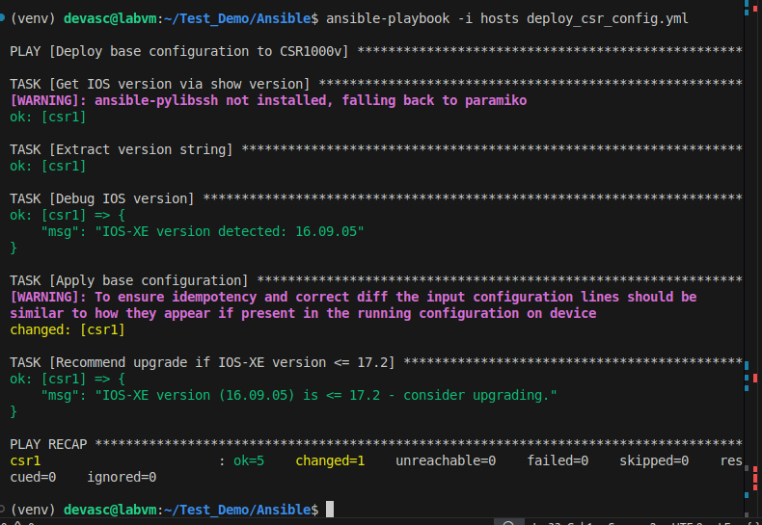
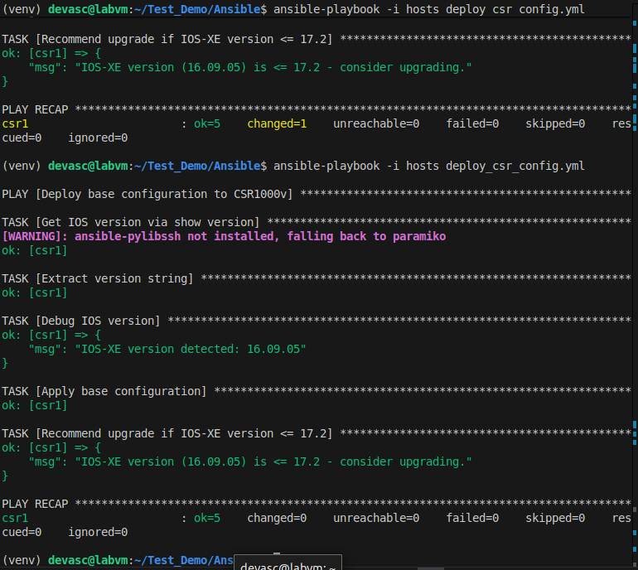

Question 5 — Basic IOS Management with Ansible Collections (20 marks)
Write a playbook: basic_telemetry_config.yml
- Use cisco.ios.ios_config
- Apply:
Plaintext
snmp-server community public RO
snmp-server location LAB-ROOM-204
snmp-server contact network-team@university.edu
- Verify configuration using:
YAML
cisco.ios.ios_command:
show snmp | include community
- Save verification output to: verify_snmp.txt
- Be run twice to show idempotence
Deliverables:
- Playbook
- verify_snmp.txt
- Screenshots (first and second run)
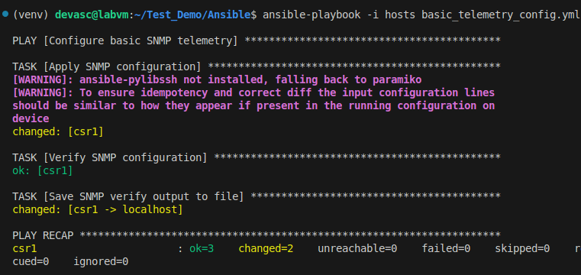
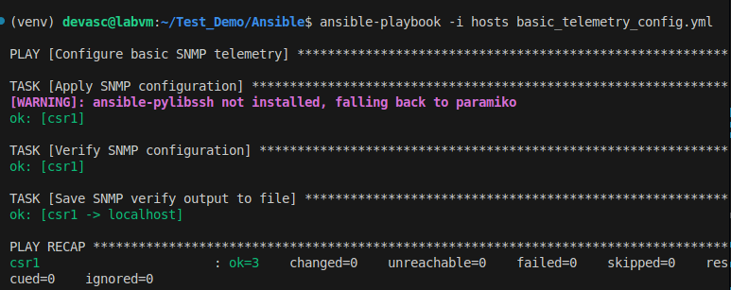
END OF EXAM

